FRAP protocol

Connor Valentine: 949-697-0183

**Experimental Protocol**

1. Sample prep
   1. Tag BSA with FITC according to protocol in google docs
   2. Make wt% pluronic samples, using the tagged BSA solution as the solvent
   3. Mix end over end in fridge for 24 hours+
   4. Loading Capillaries:
      1. Cut capillaries, slow setting on Dremel
      2. Clean cover slips (big ones)
      3. Put one capillary into each sample. Let sit 10-15 min in fridge to fill
      4. Label slide positions to note where each sample is going.
      5. One at a time, clean capillary and place onto slide
      6. Mix 5 min epoxy and quickly place one bead of epoxy on each end of every capillary
      7. Wait 20 min in the dark before moving to the microscope stage
   5. Loading sample holder grid: into the sample holder with spatula from solid state (equilibrate to room temp)
      1. First make cover slide with vacc grease lite on one side (to stick top to later). Leave to the side.
      2. Label each well with sharpie
      3. Careful not to smear one sample into the next well, load
      4. Wipe excess off each well with metal spatula, leaving a flat top
      5. Cover with dry glass slide as u go to prevent evap
      6. When all wells are loaded, cover with greased slide
2. Microscope settings
   1. Objective – 10 x
      1. Confirm 1x is on and not 1.5x
      2. Focus midway between capillary walls using the normal light
      3. Make position list
   2. LED – LED aperature as open as possible
      1. ND4 filter pushed in for LED at 100%
      2. LED at 100 ms exposure
      3. taking image every 75 seconds for 50 images, then taking once every 20 min after that for 50 images
   3. Laser
      1. FRAP exposure: 7 s at laser 100%
      2. No ND filters for the laser pushed in.
   4. Filter cube
      1. FITC HQ (grey sticker showing on right hand side of filter wheel)
   5. Heated stage
      1. Set temperature
3. Micromanager Settings
   1. Turn on micromanager
      1. Tape sample to stage
   2. Create and save position list in micromanager and corresponding .txt notes file
   3. Turn laser key to “on”
   4. tilt optical train back and out of the way
   5. put the pipette lid heat cover on top of sample
   6. Go to pos0 before starting any prebleach test
   7. Load prebleach protocol PREBLEACH MAIN
      1. Turn off timepoints
      2. Name should be “prebleach”
      3. Choose proper folder
      4. Run PREBLEACH MAIN
   8. Go to pos0 in position list
   9. Load FRAP MAIN
      1. Make sure custom time points are enabled
      2. Every 75 s 50 frames (~ 1hour) then every 20 min after that
      3. Time should be ~ 24 hours total, can stop anytime tho
      4. Skip Fr should be 1000 for the laser on setting
      5. 7000 ms of exposure for laser
      6. 100 ms exposure for LED
   10. Go to pos0
       1. Press run

**Data Analysis Protocol**

1. Upload experiment folder to Box. Do not sort data yet. Connor Valentine folder is the backup now
2. Sort Data to [Sorted Data FRAP] folder
   1. Waiting Room is just a place to wait for downloads to computer
   2. Rename the folders by pluronic type.
      1. 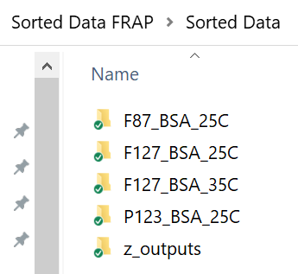
   3. Folder1 = plur_prot_tempC
   4. Within this folder, make a folder for each trial Folder2 = trial_#
      1. 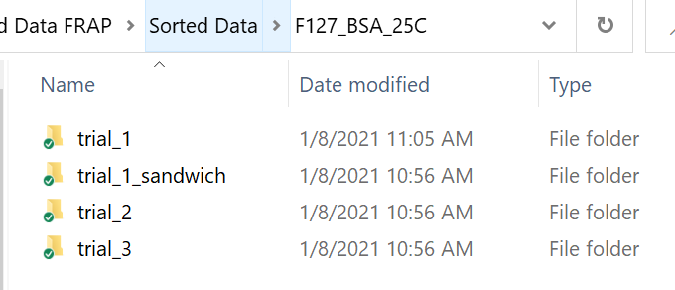
   5. In each trial folder, 3 folders must be made. Must have exact spelling including case. The .mat file in the picture will be made in the next step
      1. 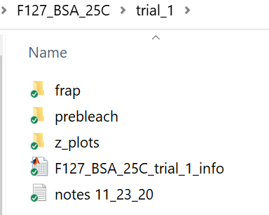
   6. Folders: frap and prebleach should just have a list of the pos# folders in them. They should be the same folder structure
      1. 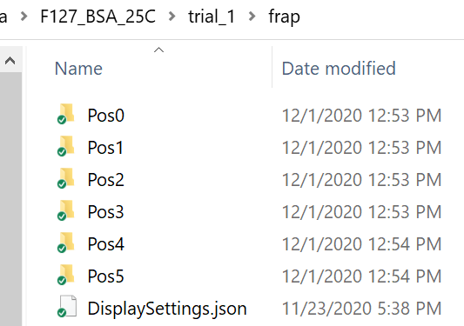
3. Run Frap_data_cleaner.m
   1. This script generates the experimet_info.mat file that is in the trial_# folder.
   2. Just need to define folder1 and folder2, and then the parameters below. 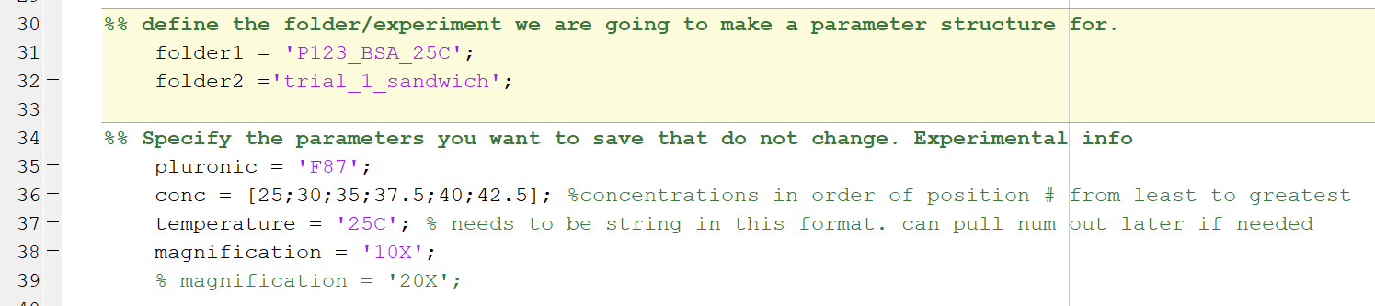
4. Run Frap_Code_V#
   1. You are now ready to run the script.